**HCB Change Approval CHG0193167 . We used this change to cover Trusts for Enterprise**



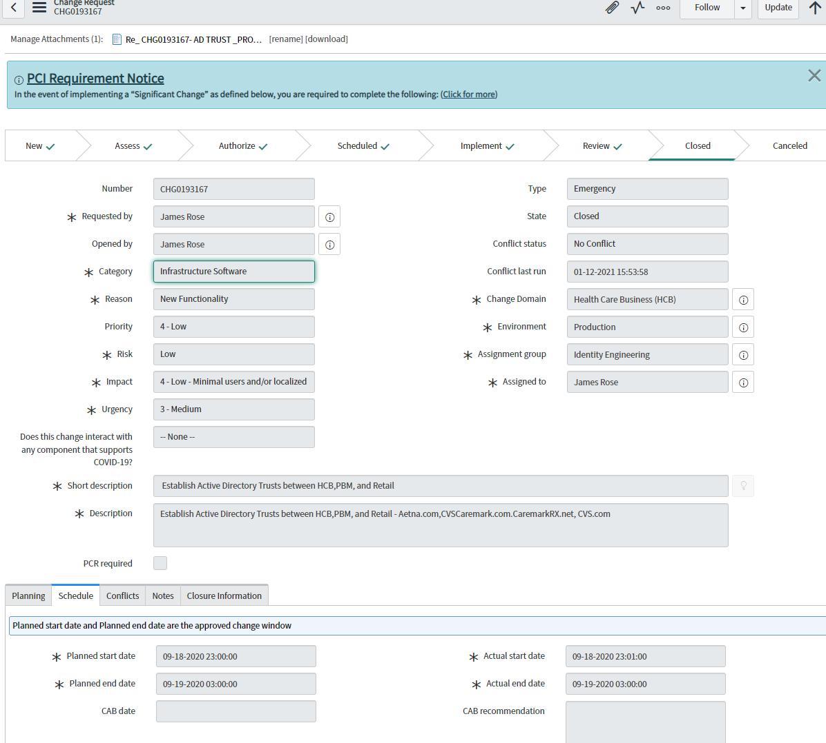

**CVS Health Trust communications between AD/Network/Firewall/Enterprise Security teams**







**AD Roadmap with Senior Leaders on progress and implementation**



